LAB 2
Demonstrate the steps to build a machine-learning model that predicts the median housing price using the California housing price dataset.

1 Download the dataset :
https://media.geeksforgeeks.org/wp-content/uploads/20240319120216/housing.csv
- Perform the describe and info steps
- Plot the histogram of each feature( Indicate what does histogram indicate on median_income and house_median_age)
- Demonstrate the process of creating a test set( write the difference between random and stratified test set)
- List the geographical features from the dataset and plot a graph to Visualize Geographical Data(what does the graph indicate w.r.t housing prices and location)
- Plot a graph to show features correlation with housing price. Which feature corelates to the maximum. Plot the graph for that with housing price and analyze what the graph indicate
- List the features that could be combined to improve correlation and plot again to see if correlation has improved
- List the features that needs to be cleaned and demonstrate the process of cleaning
- Is there any categorical data that needs to be converted to numerical? If so explain the method used to convert and code the same and show the output.
- Discuss the importance of feature scaling
- Design a pipeline inculcating (Custom transform, feature scaling and encoding). Explain how it works

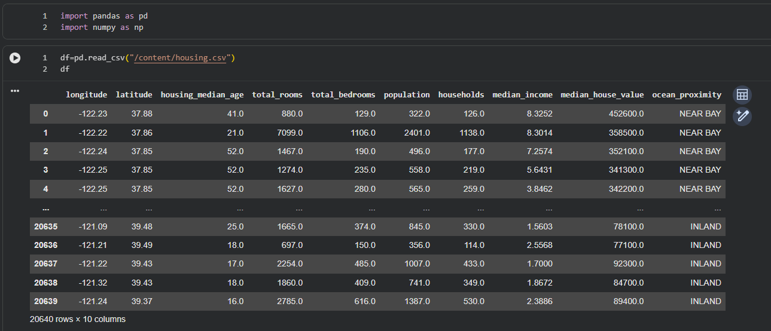

- df.describe()
df.info()
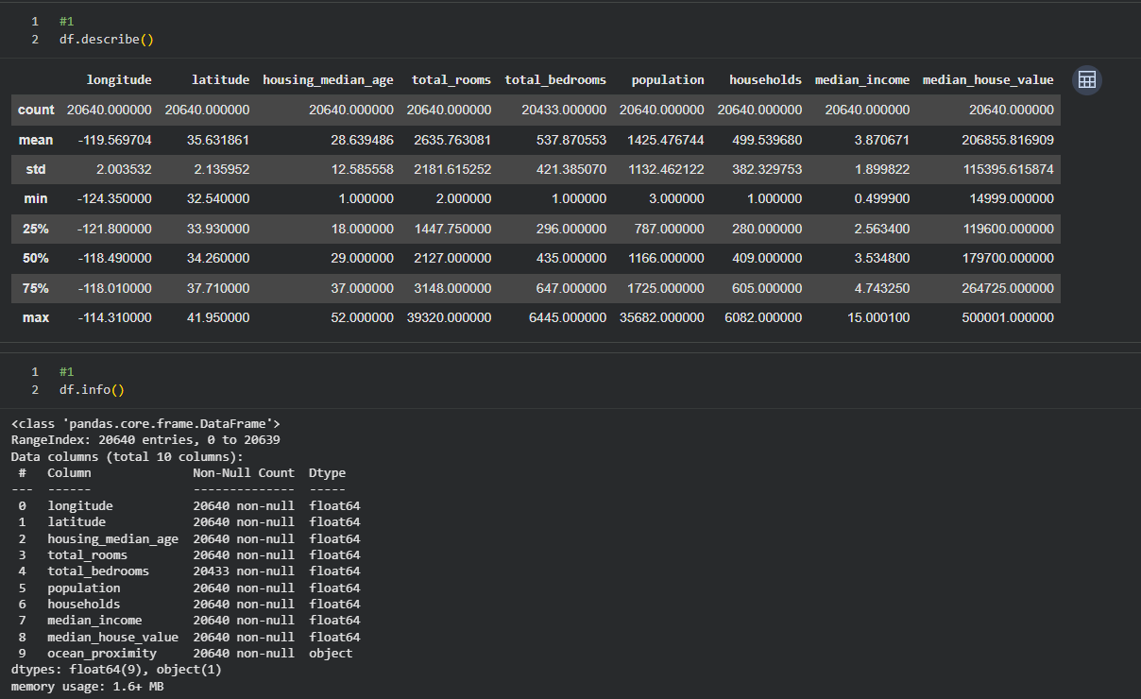

#2
import matplotlib.pyplot as plt

df.hist(bins=30, figsize=(15,10))
plt.show()

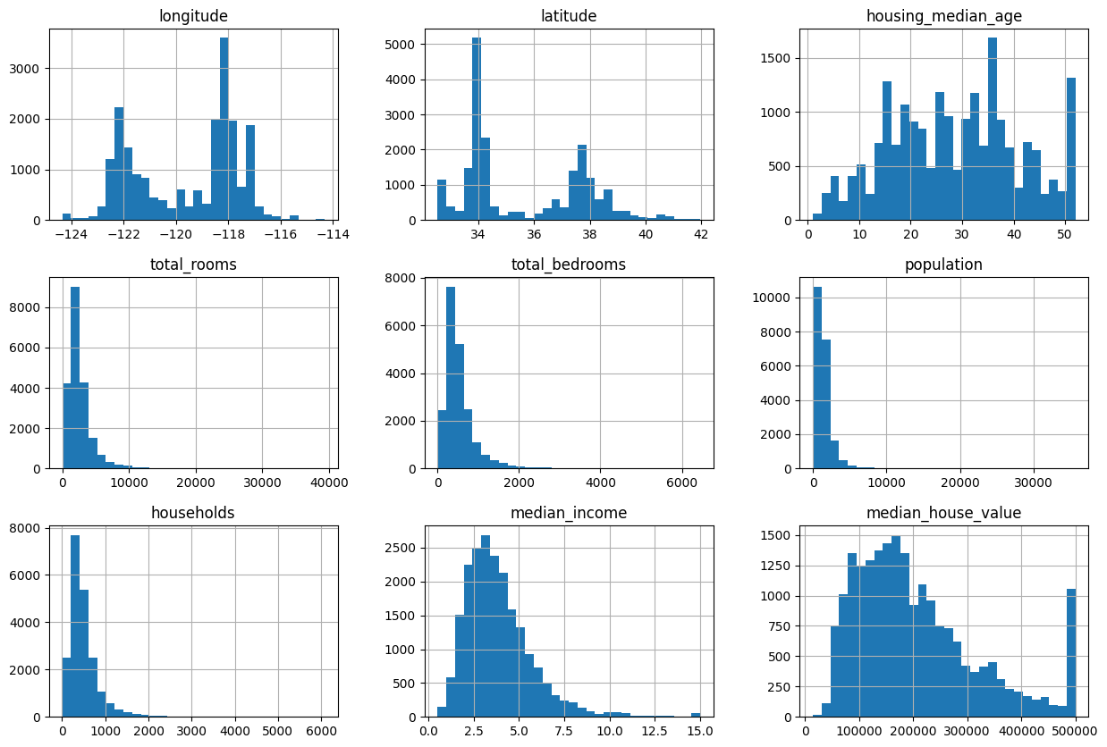

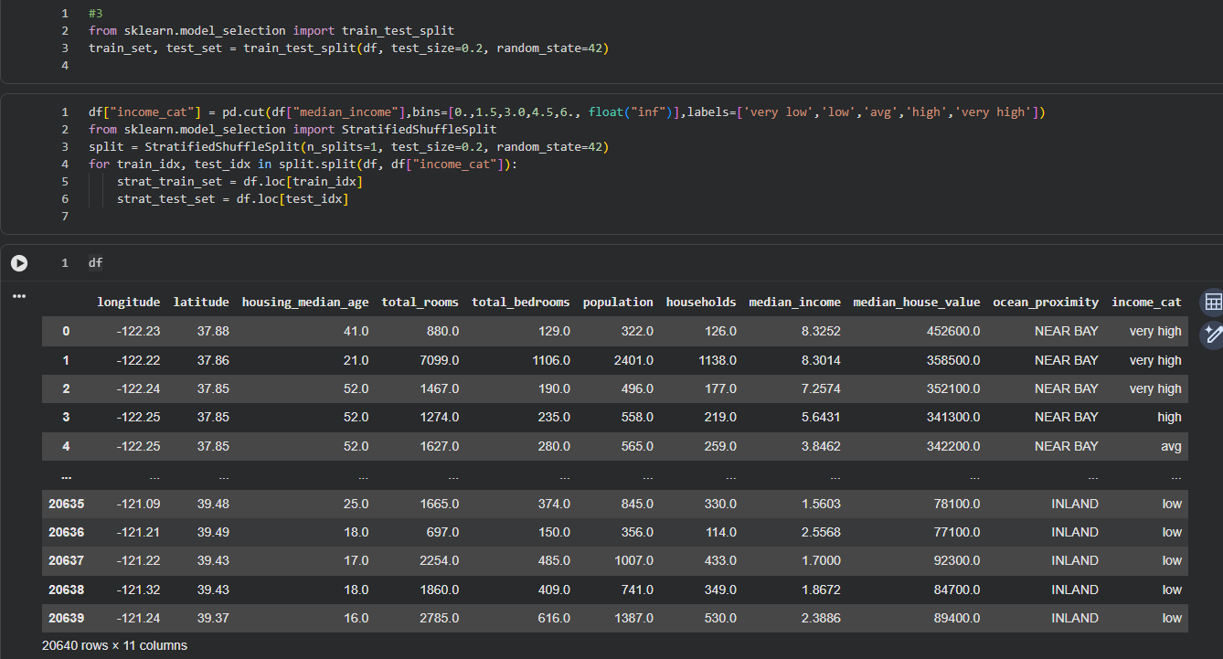

#4. Geographical Features & Visualization
df.plot(kind="scatter", x="longitude", y="latitude", alpha=0.3)
plt.show()

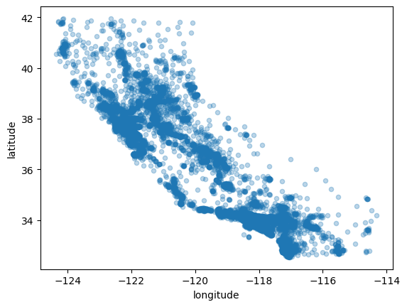

#5. Correlation with Housing Price
corr_matrix = df.corr(numeric_only=True)

corr_matrix["median_house_value"].sort_values(ascending=False)
df.plot(kind="scatter", x="median_income", y="median_house_value", alpha=0.2)
plt.show()

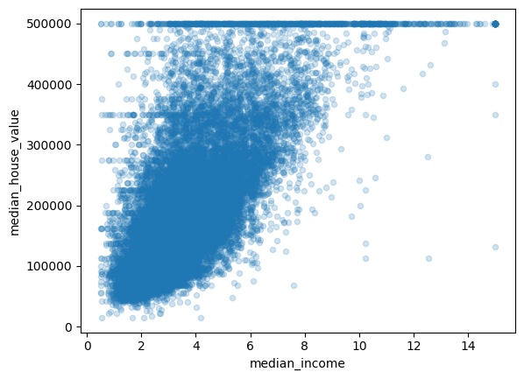

#6. Feature Engineering (Combining Features)
df["rooms_per_household"] = df["total_rooms"] / df["households"]
df["bedrooms_per_room"] = df["total_bedrooms"] / df["total_rooms"]
df["population_per_household"] = df["population"] / df["households"]
df.corr(numeric_only=True)["median_house_value"].sort_values(ascending=False)

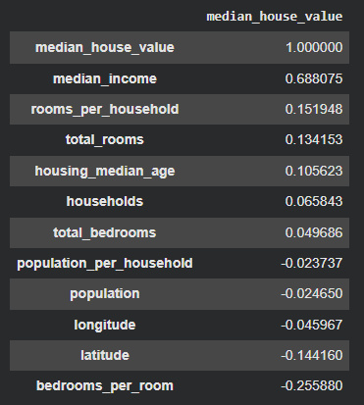

#7. Cleaning Data
from sklearn.impute import SimpleImputer
import numpy as np

imputer = SimpleImputer(strategy="median")

housing_num = df.drop("ocean_proximity", axis=1)

imputer.fit(housing_num)

housing_num_imputed = imputer.transform(housing_num)

# 8.Categorical → Numerical
from sklearn.preprocessing import OneHotEncoder

encoder = OneHotEncoder()

housing_cat = df[["ocean_proximity"]]

housing_cat_encoded = encoder.fit_transform(housing_cat)

print(encoder.categories_)

OUTPUT: [array(['<1H OCEAN', 'INLAND', 'ISLAND', 'NEAR BAY', 'NEAR OCEAN'],
dtype=object)]

#9. Feature Scaling
from sklearn.preprocessing import StandardScaler

scaler = StandardScaler()

housing_scaled = scaler.fit_transform(housing_num_imputed)

#10. Pipeline
from sklearn.pipeline import Pipeline
from sklearn.compose import ColumnTransformer

num_attribs = list(housing_num.columns)
cat_attribs = ["ocean_proximity"]

num_pipeline = Pipeline([
("imputer", SimpleImputer(strategy="median")),
("scaler", StandardScaler())
])

full_pipeline = ColumnTransformer([
("num", num_pipeline, num_attribs),
("cat", OneHotEncoder(), cat_attribs)
])

housing_prepared = full_pipeline.fit_transform(df)

printing df
df
